**Exp. 24 Student Attendance System**

**Aim:**

To create a simple cloud software application for Students Attendance System using any Cloud Service Provider to demonstrate SaaS include the necessary fields

**Procedure:**

* Sign in to Azure Portal
* Create a resource group
* Create the Payroll Logic
* Deploy on Azure App Service (as SaaS)

**Output:**

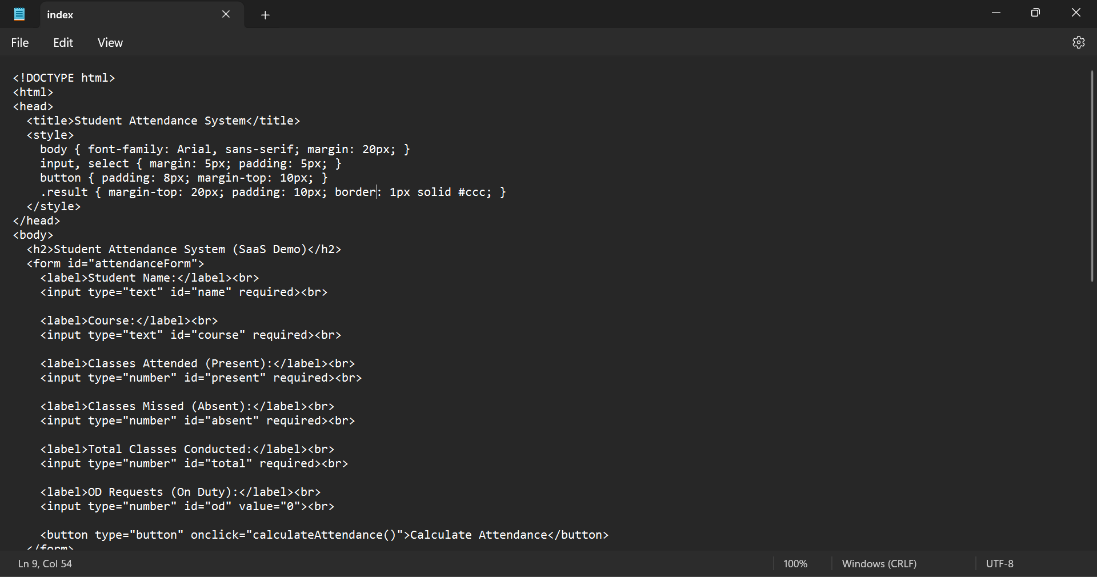

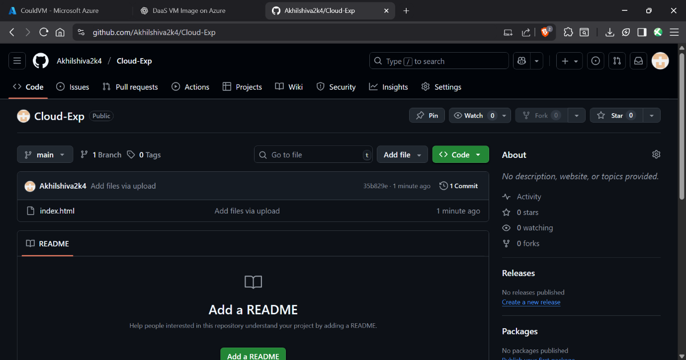

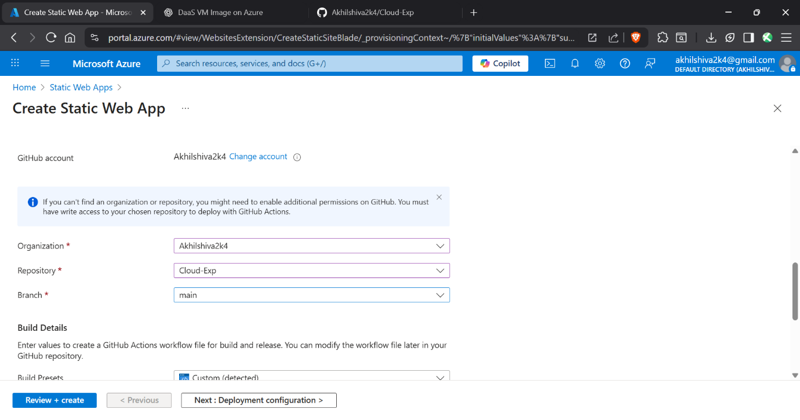

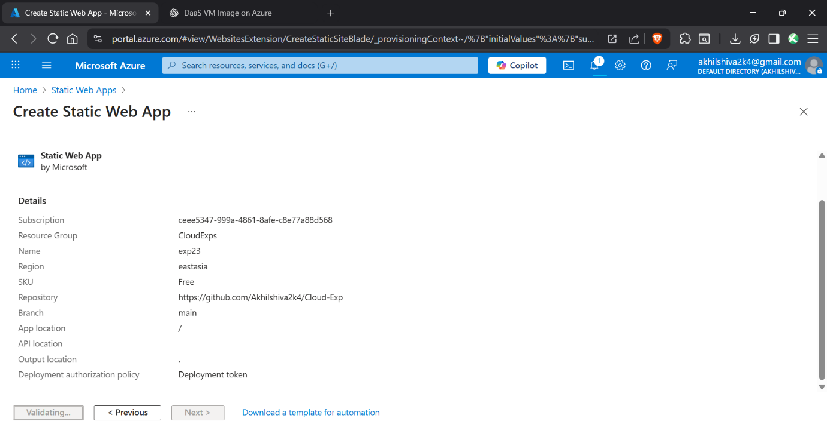

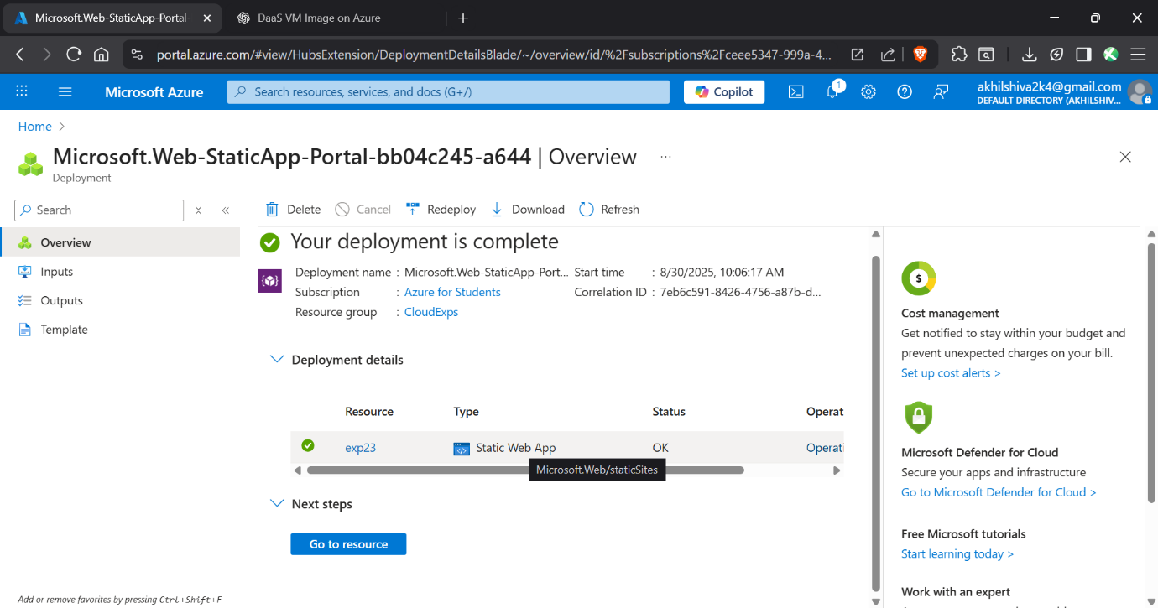

**Result:**

Thus, a Student Attendance system was developed and deployed